Student Name: Azeem Arshad Vasanwala  
Email: avasanwa@asu.edu  
Submission Date: 11 Feb 2022  
Class Name and Term: CSE468 Spring 2022

Lab 1

# Project Overview

Over the course of this lab, I created 3 virtual machines (VMs) to simulate a client, gateway and server. I linked up the client and server and connected them to the gateway which provided both client and server VMs access outside of their local networks. The gateway was configured to forward traffic to the host machine, and as such the VMs could access the internet once routing was set up for the client and server and the gateway was able to forward traffic to the host machine via NAT.

# Network Setup

This is optional, more for the first lab,

Draw a diagraph and provide descriptions about the network setup, include:

* topology,
* network configurations (IP addresses, etc.)
* initial reachability among network nodes

# Software

Describe major software and network services are used in this project to accomplish your goal.

* VMWare Fusion
* Ubuntu 20.04
* iptables
* ifconfig

# Project Description

My laptop is a 2021 MacBook Pro running an M1 chip. As a result, it was difficult to set up the VM as virtualization software is mostly made for x86 machines. I got Dr Deng’s help to set up VMWare Fusion for Apple Silicon with an Ubuntu for ARM image. I will present the key steps I took here.

1. Download VMWare Fusion for Apple Silicon from here: <https://blogs.vmware.com/teamfusion/2021/09/fusion-for-m1-public-tech-preview-now-available.html>
   1. Install VMWare Fusion for Apple Silicon
2. Download the 64-bit ARM image for Ubuntu 20.04 from here: <https://cdimage.ubuntu.com/focal/daily-live/current/>
3. Create a new VM using the image downloaded. We will first create the Gateway VM and base the client and server off that VM
   1. First, add the ISO file and enter the configuration page  
       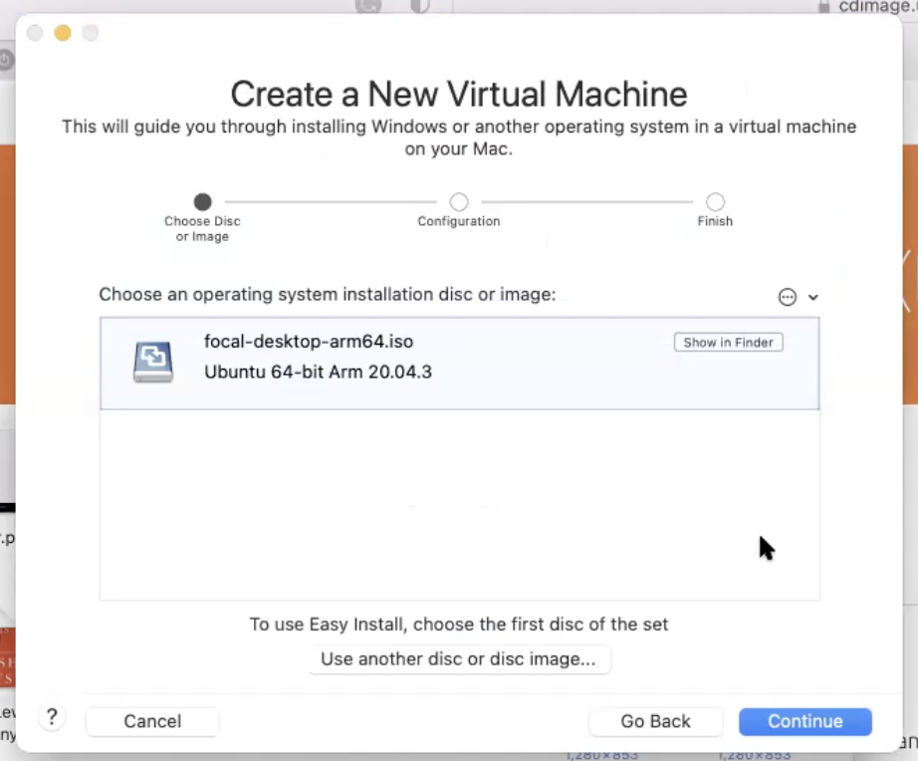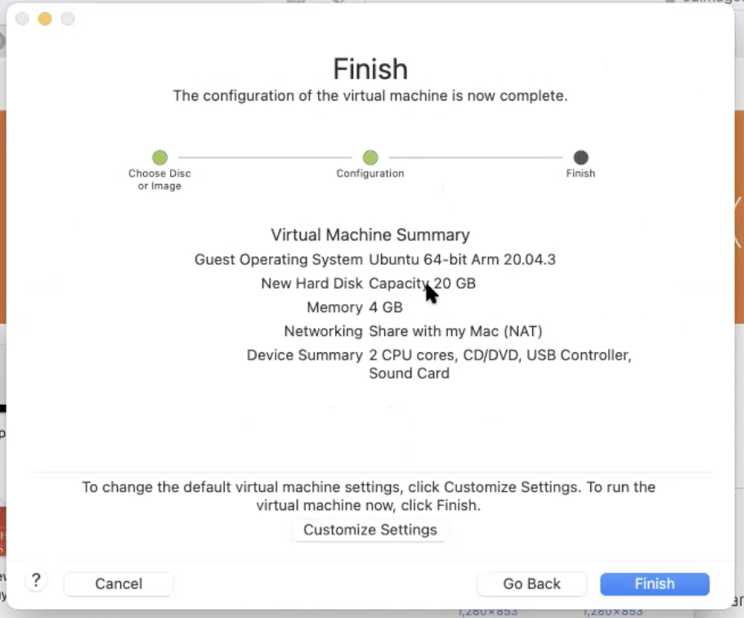
   2. Click on “Customize Settings” and add 2 more network adapters under “Add Device”  
      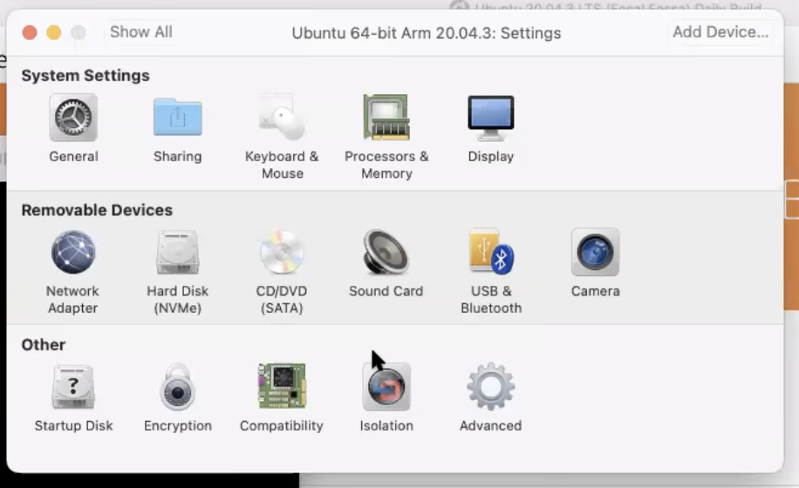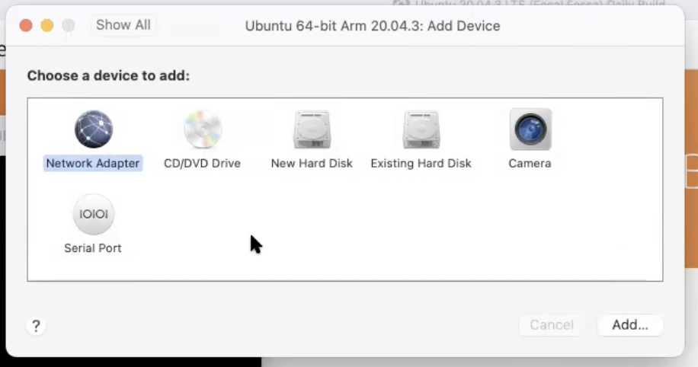
   3. Go to VMWare preferences > Network, and add 2 networks. Name them Network 1 and 2. These will be networks described in the lab guide on page 1. Uncheck “Connect the host Mac to this network” and “Provide address on this network via DHCP”. Network 3 will be the one connected to the Host machine, under “Shared with my Mac”.  
       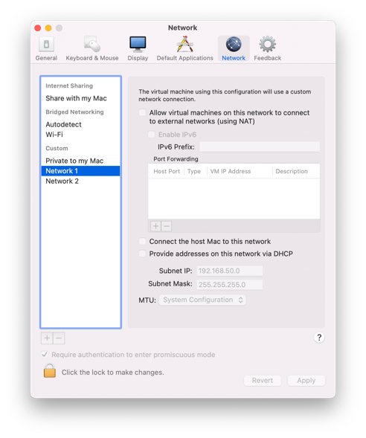
   4. Open the VM settings, and connect Network Adapter 1 to Network 1, Network Adapter 2 to Network 2, and Network Adapter 3 to “Shared with my Mac”  
      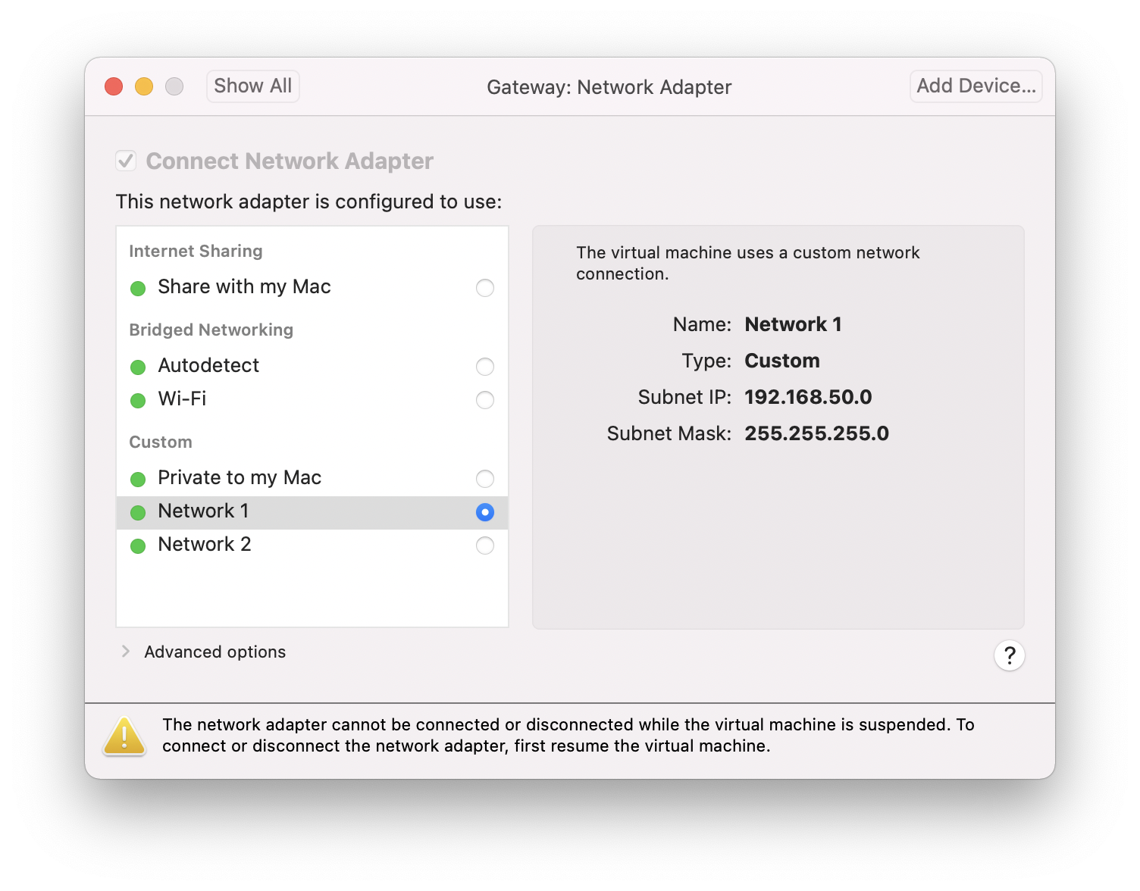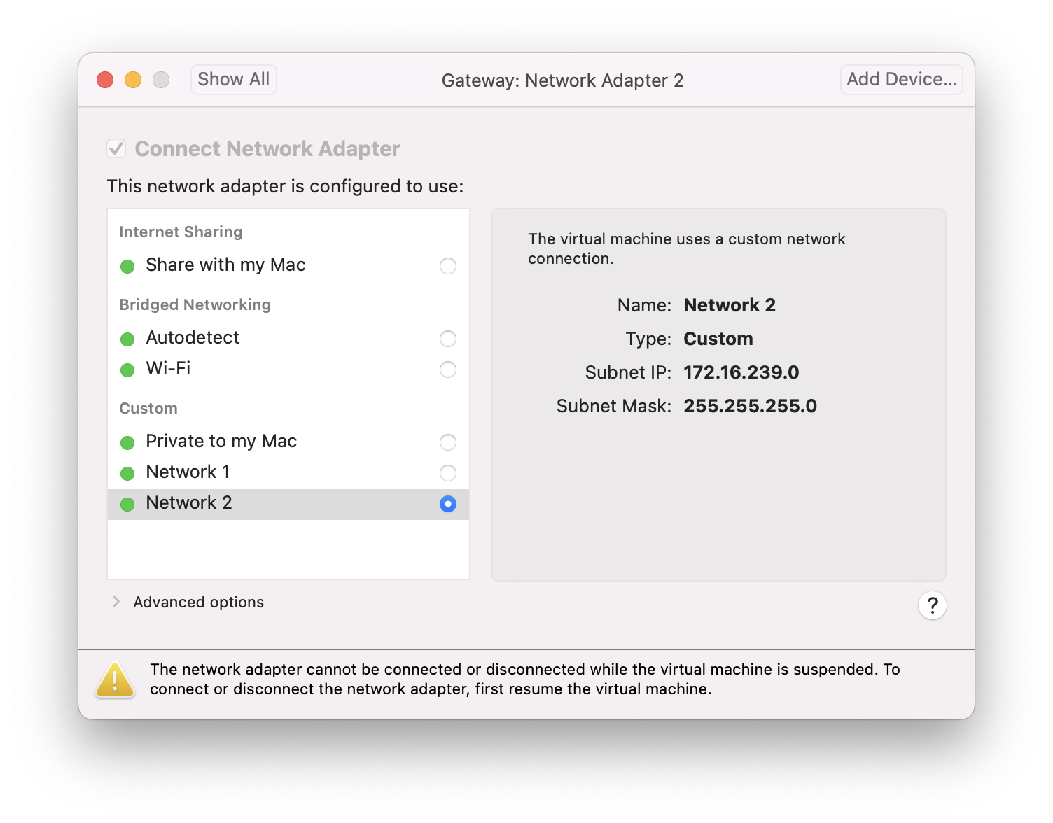  
      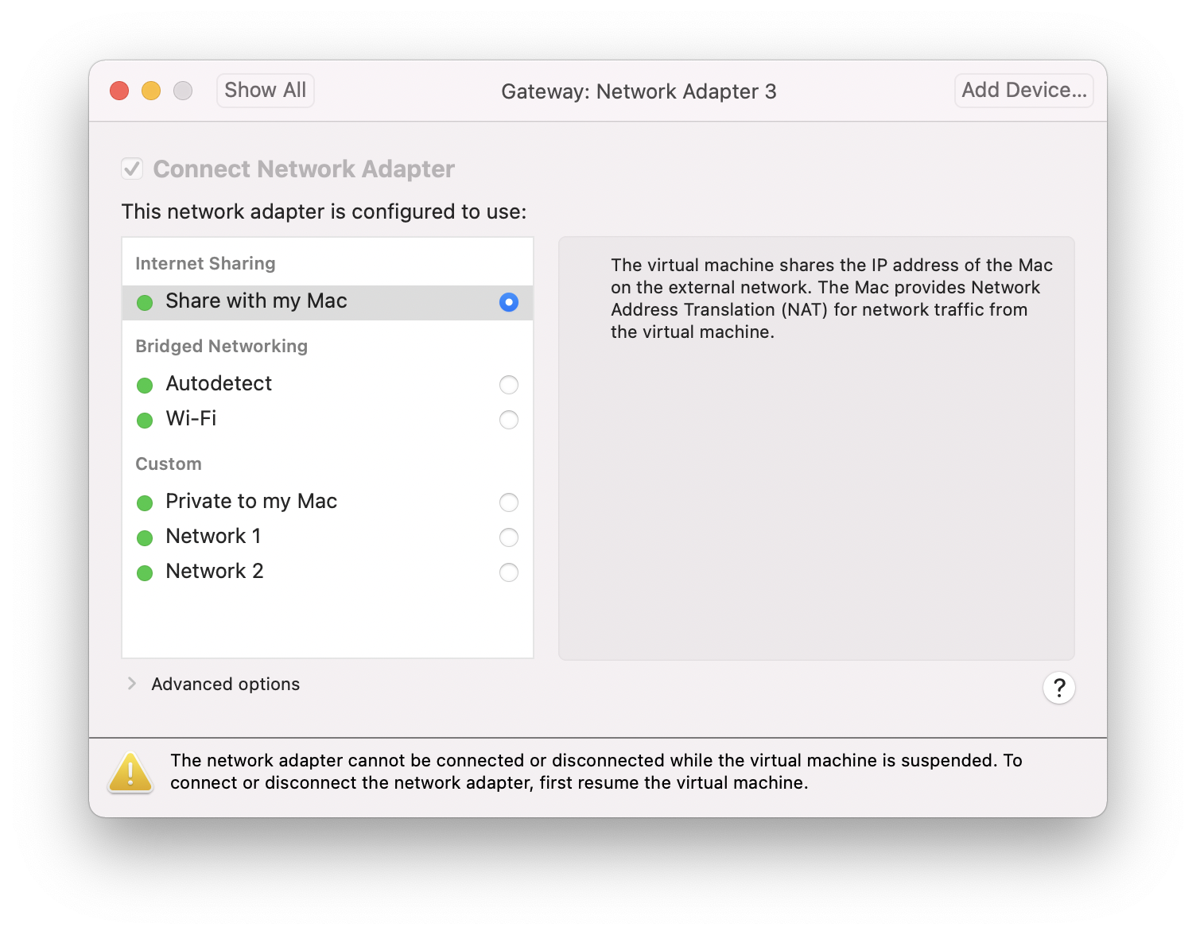
   5. Start the VM and go through the setup to create your own account and password. When asked, select a “Normal Installation”.  
      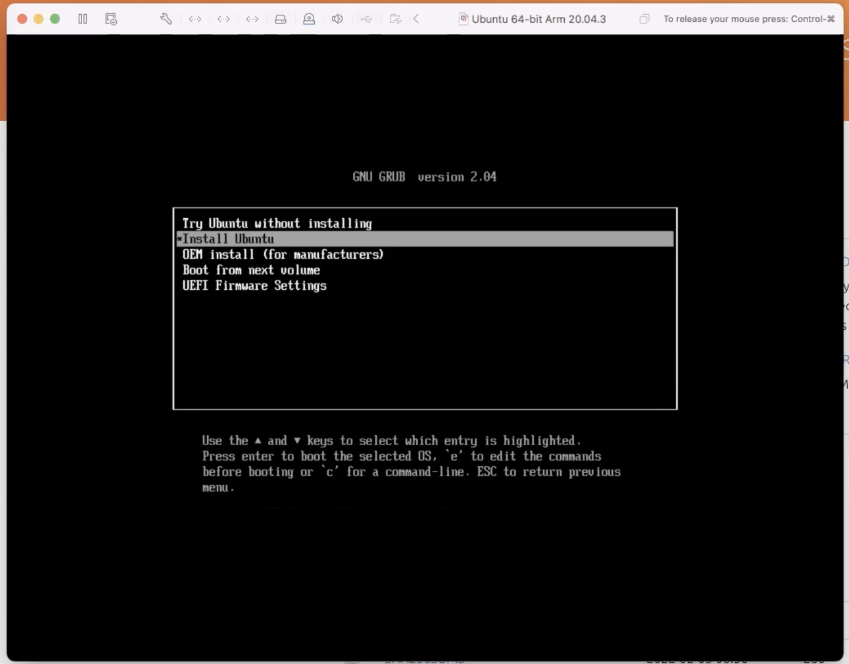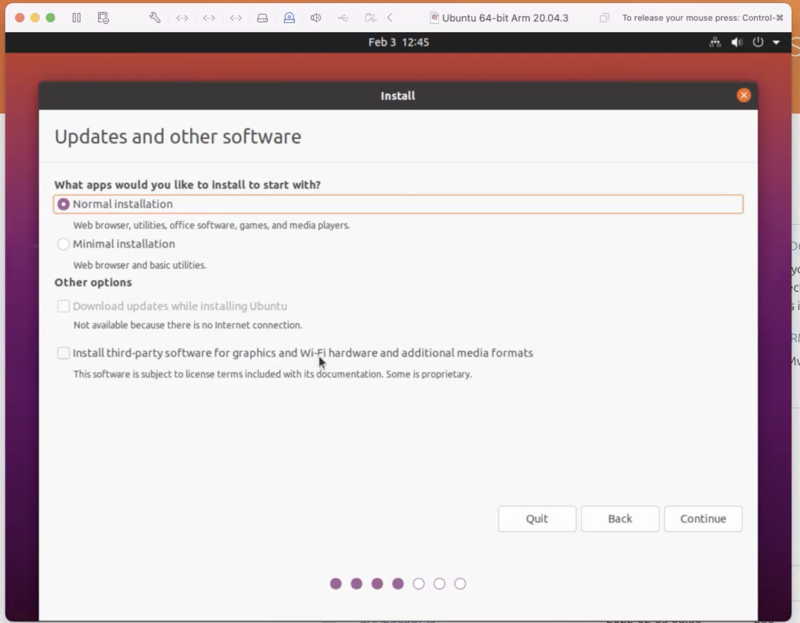
   6. Select “Erase Disk”  
      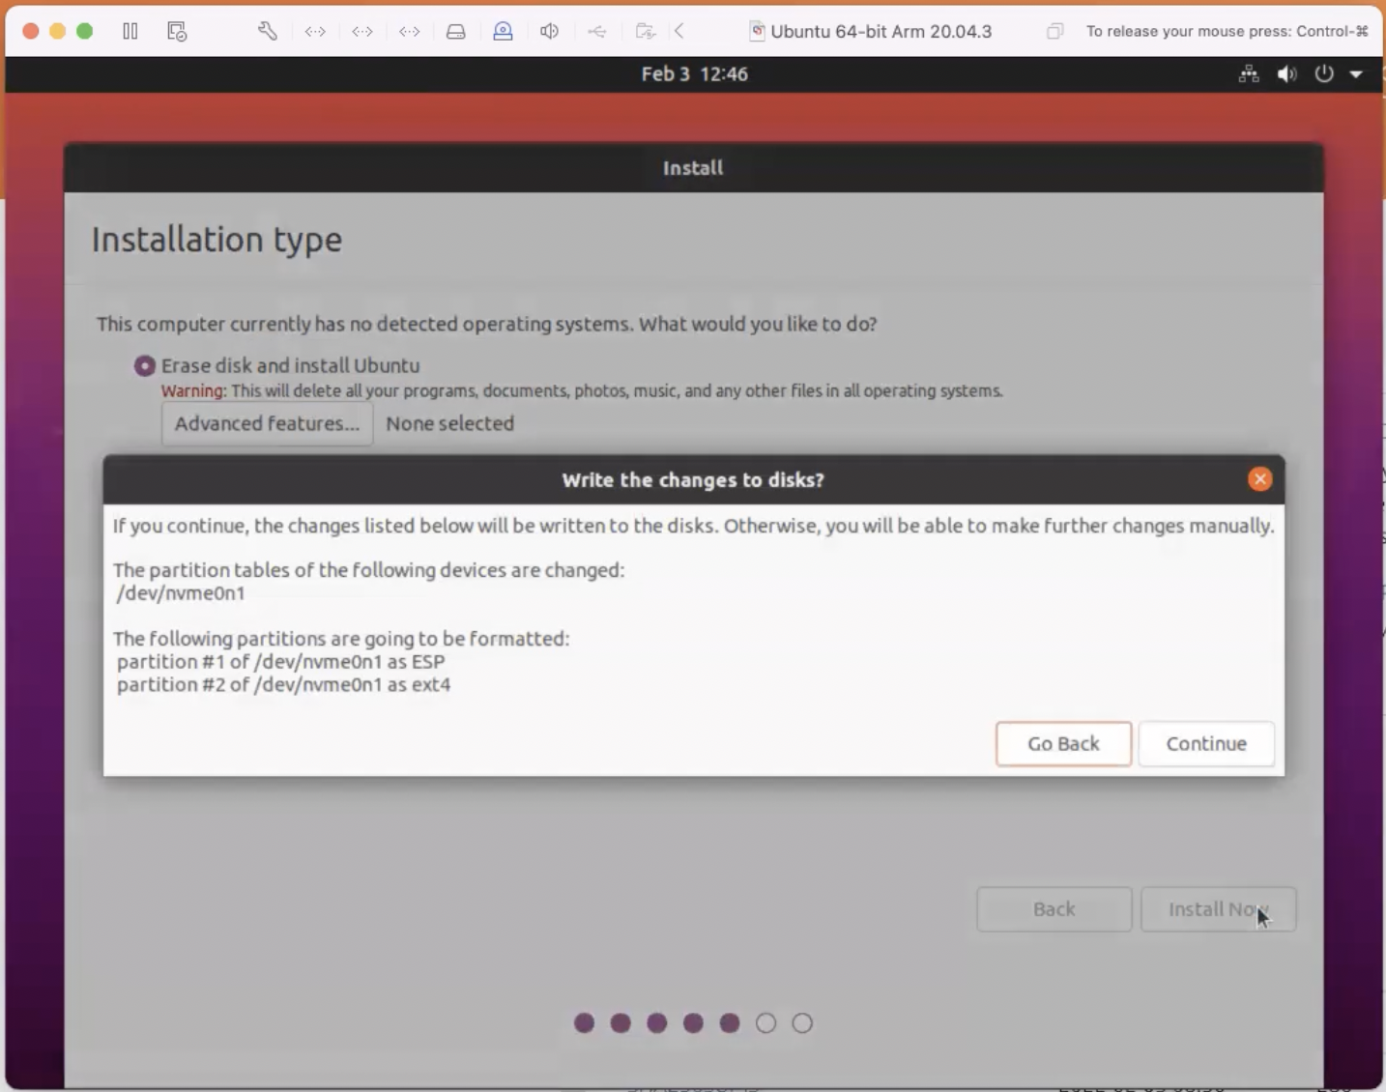
   7. Once the installation is complete, open the terminal and run the following commands in order:
      1. *sudo apt update*
      2. *sudo apt install ifconfig*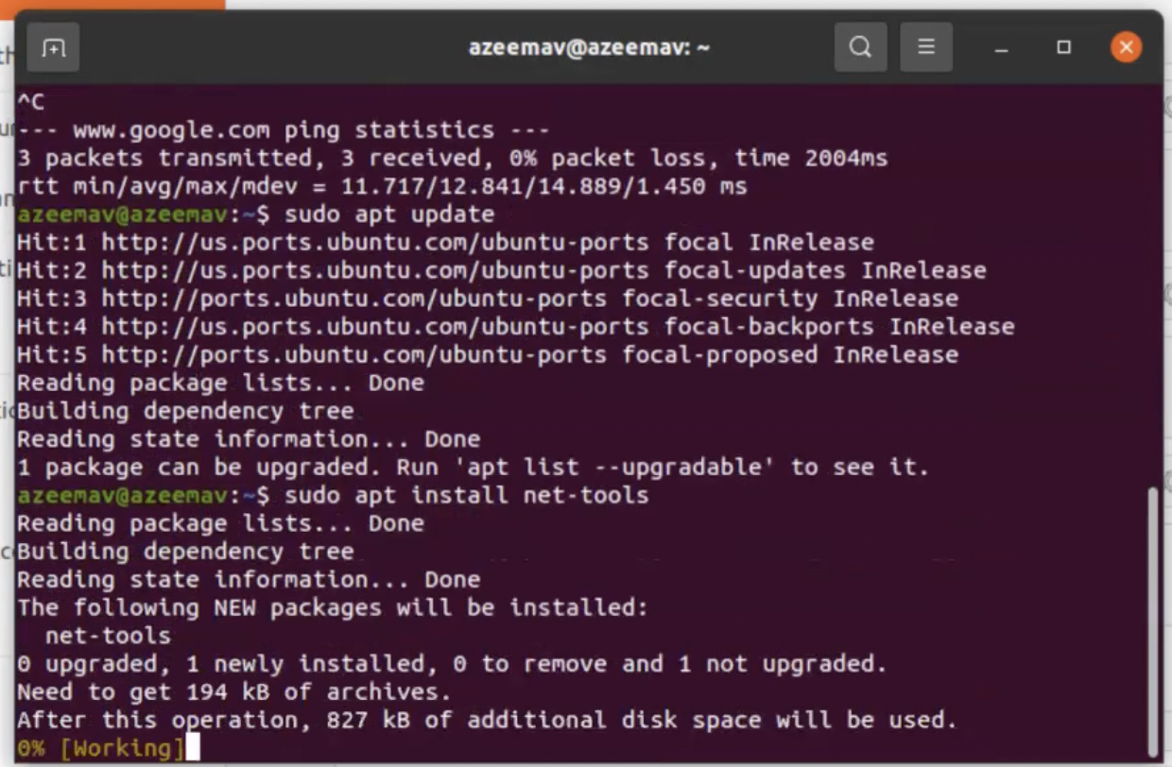
      3. *sudo apt install iptables*
      4. *sudo apt install wireshark* (this is needed for future labs)
      5. *sudo apt install nmap*
   8. Now, shut down the VM and get ready to clone it
      1. Rename the VM to gateway  
         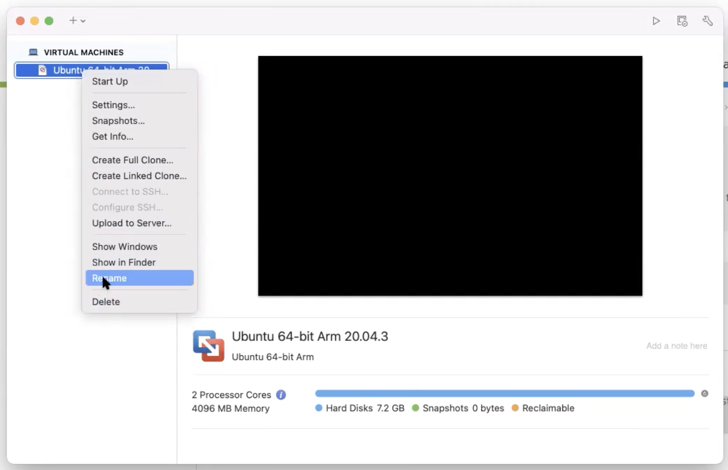
      2. Create a Linked Clone of the VM and name it “Client”. This saves space as opposed to a full clone. We will do this step twice.  
         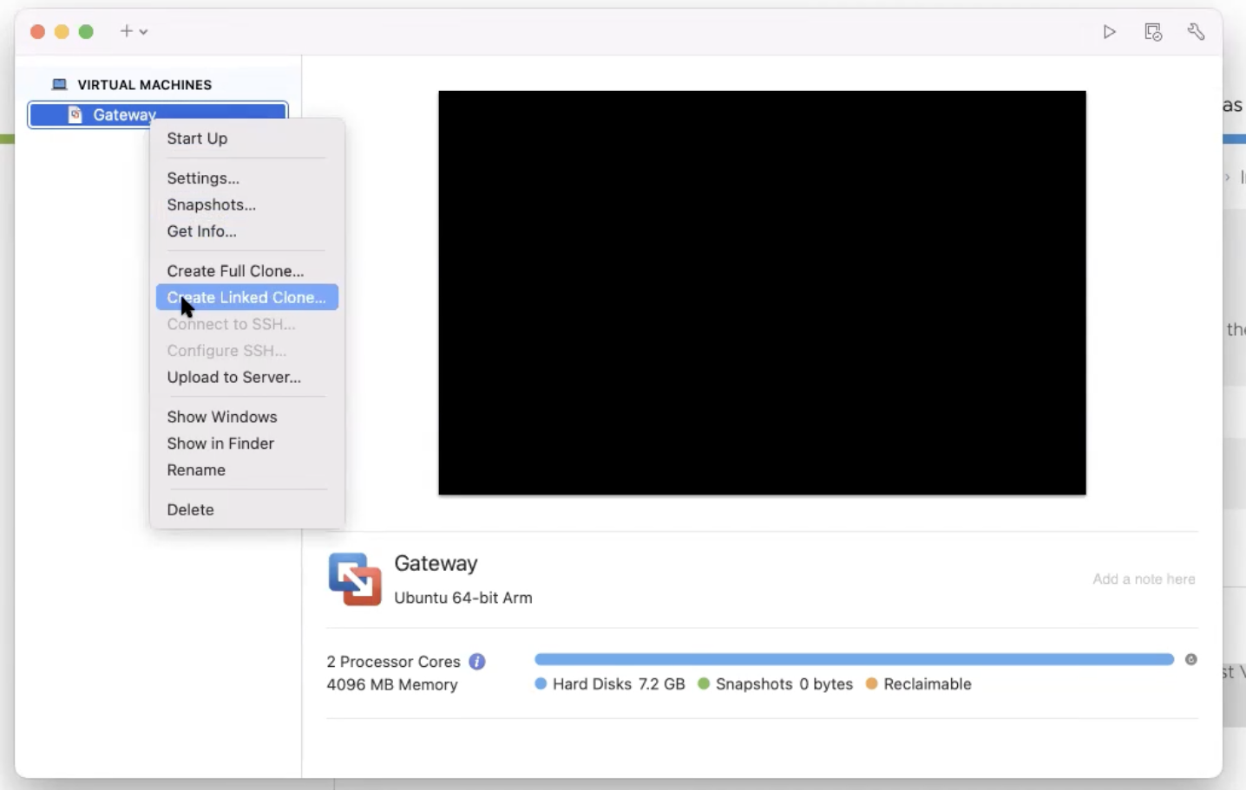
      3. For the first linked clone, delete network adapters 2 and 3. For the second linked clone, name it “Server” and delete network adapters 1 and 3. Deleting network adapters can be done by going into the adapter settings > advanced > remove network adapter.  
         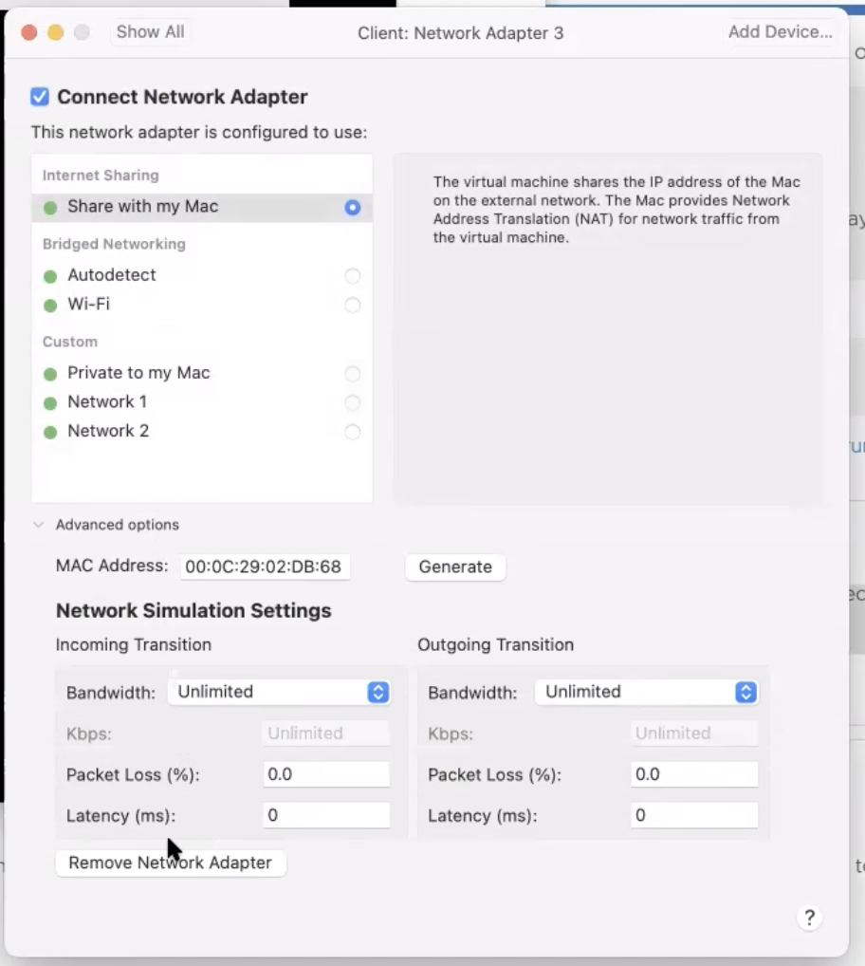
      4. Once done, start all 3 VMs
4. We are now ready to configure the VMs as required by the lab. We will first connect the client VM to the gateway.
   1. Run *ifconfig* in the client to list our network interfaces. In my case, I have 1 interface named *ens160*. We will bring up the interface with the IP address 192.168.0.10/24 by running *sudo ifconfig ens160 192.168.0.10/24 up*  
      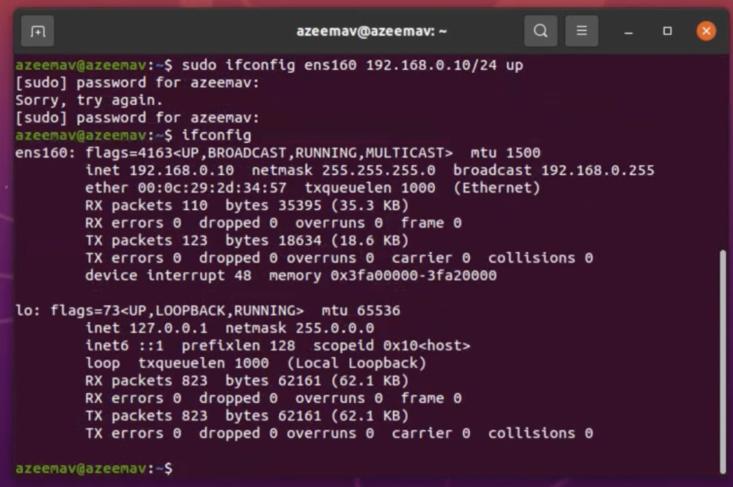
   2. We now bring up the gateway’s interface 1 with the IP 192.168.0.100/24. Similarly, we list the interfaces using *ifconfig*, and then bring up the first interface using *sudo ifconfig ens160 192.168.0.100/24 up.*
   3. Following that, we can ping the client from the gateway using *ping 192.168.0.10* and see if we get a response, which we should since they are both and the same network  
      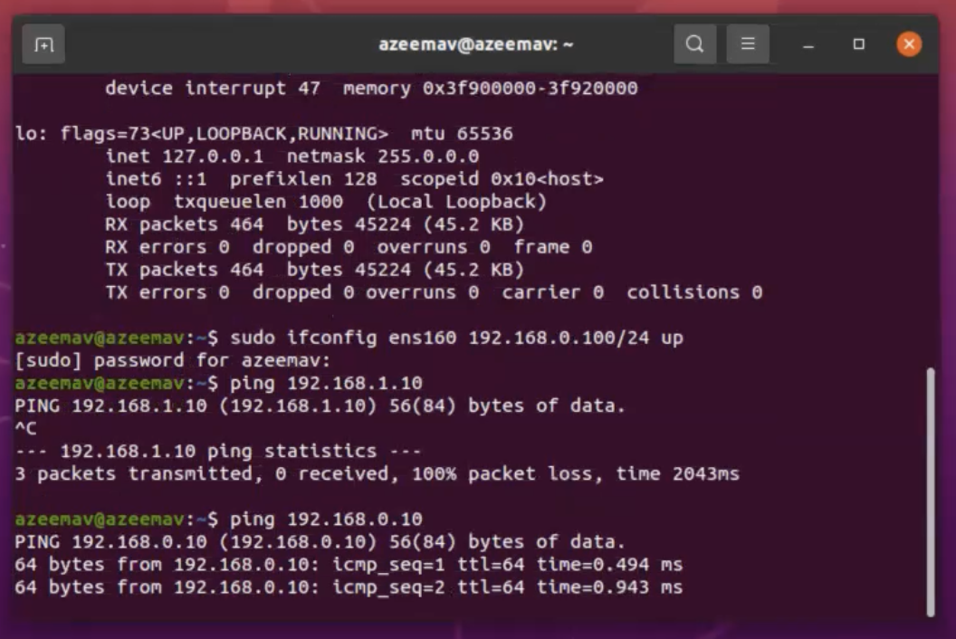
   4. Once connectivity is established, we can permanently configure the network configuration of the client
      1. We navigate to */etc/netplan* using *cd /etc/netplan* and create the configuration file using *sudo nano 01-netcfg.yaml*
      2. Copy in the content from client.yaml (located at cse468-labs/Lab-01/config-files/client.yaml) and save the file. Ensure you update the name of your interface if it differs.
      3. Run *sudo netplan apply* to apply the configuration.
5. We will now set up the server. The steps are identical to Step 4, replacing client.yaml with server.yaml instead.
6. We will now finish up the configuration for the server.
   1. First we ensure that we are able to provide the 3rd interface on the gateway with an IP address using *sudo dhclient ens224.* Replace *ens224* with the interface identifier for the 3rd interface for your own gateway machine
   2. Navigate to */etc/netplan* using *cd /etc/netplan* and create the configuration file using *sudo nano 01-netcfg.yaml*
   3. Copy in the content from gateway.yaml (located at cse468-labs/Lab-01/config-files/gateway.yaml) and save the file. Ensure you update the name of your interface if it differs.
   4. Run *sudo netplan apply* to apply the configuration.
   5. Run *iptables -t nat -A POSTROUTING -o ens224 -j MASQUERADE* to set up the NAT for communication with the internet from the client and server
   6. Run *sudo sysctl -w net.ipv4.ip_forward=1* to enable IP forwarding
7. We are now done, we should be able to fire up a web browser on each of the VMs and access the internet from all of them.

# Conclusion

I learnt how to forward traffic from one network interface to another by setting up routing rules using iptables. I also learnt how to set up virtual interfaces within a hypervisor’s ecosystem so that different VMs can talk to each other. I think I picked up what I needed to do fairly quickly, and was able to extrapolate the setup for the server VM once I had set up the client VM.

# Appendix B: Attached files

Provide a list of used configuration and developed source files (or gitlab/github links). In your configuration file, please with well marked comments. A good practice is to provide comments where you made changes, something like:

// Your Name: comments

# Your Name: comments

/*

Your Name: comments

*/

The comment format depends on your used system files and programs.

# References

Reference is optional, but nice to have to allow others to read your report with additional linked source for validation and learning.

1. Wireshark, available at <https://www.wireshark.org/>, accessed by 8/31/2018.
2. Postel, Jon. "RFC 791: Internet protocol." (1981).